Group Programming Project I CS 150
Computer Programming for the Liberal Arts 100 points

This programming project should take no more than two weeks to complete, especially since it is a group project.
Step 1: Form a group of two or three.
Step 2: Choose one of the three projects below and complete the associated instructions. Decide which functions should be implemented, and consult the instructor if you need guidance.
Step 3: You will be required to explain the logic of your project code during the presentations, according to the schedule posted on Moodle.

Submission
Submit the 1. Project code, and 2. Project report using Github. You will present your project as a group in class on either Wednesday (April 8) or Friday(April 10) .

Project Report Guidelines:
Your project report should be 1/2 to 1 1/2 pages, and address all of the following considerations:
1. Introduce the project problem you chose, including a few background details (ex: a sentence or two regarding the history of the Rubik's cube would be appropriate for topic 3).
2. Provide basic documentation as to how your code is to be used by somebody unfamiliar with your implementation (ex: is it a user prompt, a class with methods that a user must invoke, etc.)
3. Provide technical details including the following:
- What functions/methods you created to solve the problem, if any.
- What data types and collections you used for variables/storage
- What standard and/or third-party libraries, classes, and functions you have employed.
4. Explain any aspects to your chosen problem that you initially set out to tackle that you were unable to do so, or anything that isn't quite working correctly, and what you believe the issue to be. (If nothing applies here, you should state as much.)
5. Explain in a paragraph or so how your code could be built upon to solve a larger scale problem or include additional features that were not present. Note: I will be extremely flexible about your choice here, but you must put something.
Project Presentation Guidelines:
- Introduction:
  - Introduce yourself and your project team.
  - Provide a brief overview of the project's purpose and objectives.
- Project Overview:
  - Describe the problem that your project addresses.
  - Explain what you were able to implement, as well as anything that you could not complete (or would like to have completed).
- Implementation:
  - Walk through the key elements of your project's implementation, include collections, variables, and libraries/classes used.
  - Note that the instructor will ask questions regarding specific details -- be prepared to answer these!
Project Options:
Option 1: You are to implement the game “Mastermind” (Number Version) vs the computer.
The computer will generate a secret 4-digit number, and the user must guess it. | 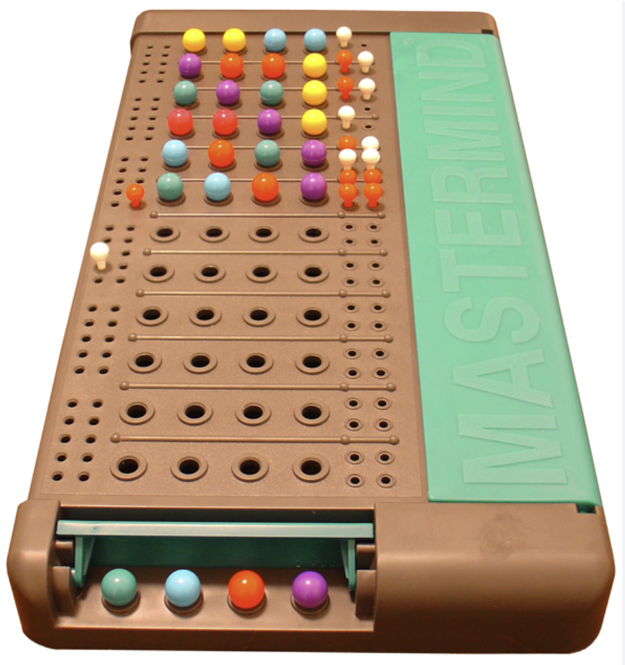
You are to take the following steps:
- The computer randomly generates a 4-digit number (digits 0–9)
- Prompt the user to guess the number
- After each guess, give feedback:
  - Number of correct digit in the correct position
  - Number of correct digit but in the wrong position
For example, if the secret number is 1234 and the user guesses 1325, the program should indicate:
- 2 digits are correct and in the correct position
- 1 digit is correct but in the wrong position
If the user finds the secret number, display a message informing them that they have won. Then end the game and ask if they would like to play again
Since this is a relatively easy program to create, you must also
- Limit the number of guesses (for example, 10 attempts)
- Tell the user whether they win or lose at the end of the game
- Let the user choose whether or not to play again
- Keep track of the record so far (# wins, # losses)
- Display the record after the end of each game

Option 2: You are to create a simple version of the game Minesweeper
(https://en.wikipedia.org/wiki/Minesweeper). I am flexible about how you choose to implement the game, with the following requirements: | 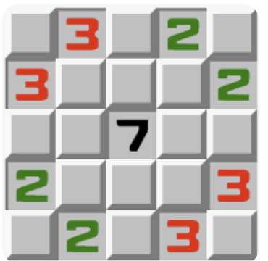

- The game should use a small grid (for example, 5 × 5).
- The program should randomly place a small number of mines in the grid.
- The user should choose a square by entering its row and column.
- If the user selects a square containing a mine, the game ends and the user loses.
- If the user selects a square that does not contain a mine, the program should display how many mines are adjacent to that square.
Since this is a relatively easy program to create, you must also
- Keep track of which squares have already been revealed
- Prevent the user from choosing the same square more than once
- Detect when the user has won the game by revealing all non-mine squares
- Let the user choose whether or not to play again
Note: You may implement the game using graphics, but the easiest way is probably to print the grid after each move. Hidden squares, revealed squares, and mines can each be shown using different symbols.

Option 3 (Tricky!): You are to implement a class that represents a virtual Rubik’s Cube
(https://en.wikipedia.org/wiki/Rubik%27s_Cube). The class should store the state of the cube and provide operations to manipulate it. I will be flexible about how you represent the cube internally, but at a minimum your program must include the following functionality. | 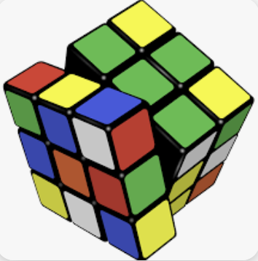
- Store the colors of all 54 visible square faces of the cube (you may use lists, arrays, or any other suitable data structure).
- Include a constructor that creates a cube with an initial configuration of colors (this can be the standard solved cube or a randomly generated configuration).
- Provide operations to rotate the cube in at least two of the six possible directions (for example: rotating the front face or the top face). Note: correctly updating the cube after a rotation can be tricky!
- Provide a way to display at least one face of the cube (for example, the front face). This can be done by printing the colors in a grid format, although using graphics is also acceptable if you prefer.

